SUMMARIZER
The summarizer explains what happened in previous passages.
Uses own words to explain key ideas.

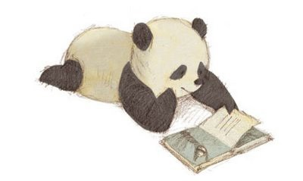
This paragraph is mostly about…
The author is trying to tell me…
The summary of the paragraph is…
The key ideas are…

QUESTIONER
Asks a question about a passage.
I search, ask, and investigate.

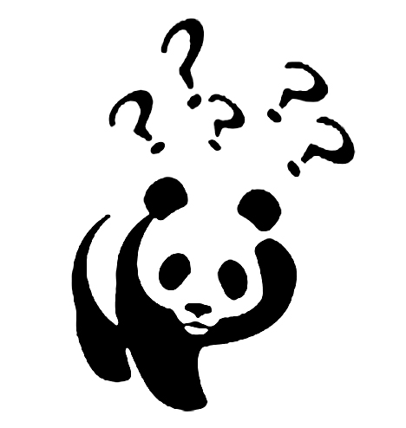
What questions do you have about the topic?
What did you think about as you read?
Share what you think the author meant when?
What else do you know about this subject?

I have these questions about the topic…
While I was reading, I thought about…
The author meant…..when he/she said…
This is something else I know about the topic…

PREDICTOR
Makes guesses about what a passage might be about a passage,
or what might happen next.
I guess, infer, and speculate

What do you think will happen?
What will the author do or tell you next?
What clues tell you what will happen?
What clues from the passage help you remember what has happened?

I predict that…
I infer that…
I think that…because…
I speculate that…
CLARIFYING
Picking out words and/or phrases which are new or difficult
When I clarify, I explain, define, identify, monitor
I need help understanding this part of the section.
What context clues help you?
The words that I don’t know or I don’t understand are…
Add another example to figure out the meaning
I don’t understand the word…
One word I don’t understand is…
What does it mean when…?

