Spelling options for /k/

When to use ‘c’, ‘k’, and ‘ck’

In 1-syllable words use the letter ‘c’ with the vowels a, o, u.
‘c’ is the most common spelling for /k/ at the beginning of words.

Examples: cap cop cup
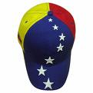



Use the letter ‘k’ with the vowels i and e.


Examples: kit Ken kin



Use the consonant digraph ‘ck’ only at the end of 1-syllable words when the /k/ sound IMMEDIATELY follows a vowel.

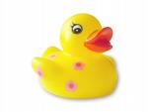
Examples: dock quack brick



