**Equation** - the act of making equal

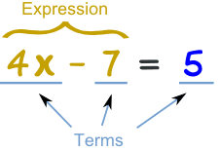

**Variable** – a symbol that represents a quantity

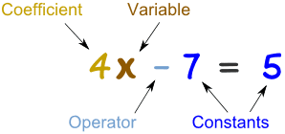

**Inverse** – the direct opposite



**Balance** – to be equal or proportionate to

