Free Text-to-Speech for Mac Users

Under ‘Launchpad’
Select ‘System Preferences’

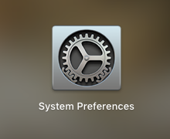

Select ‘Dictation & Speech’

’ 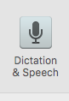
Select ‘Text to Speech’
Select ‘Speak selected text when the key is pressed’ - Current key: Option+Esc

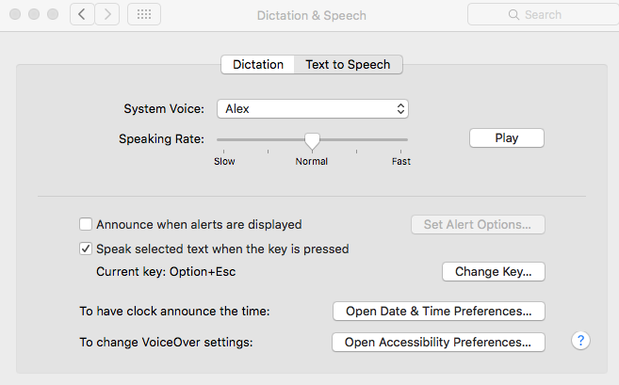

Free Text-to-Speech for Windows 10 (PC) Users

Under ‘Settings’
(for older versions of Windows go to ‘Control Panel’/’Ease of Access’)
Select ‘Ease of Access’

Select ‘On’ under ‘Narrator’



