Free Speech-to-Text for Mac Users

Under ‘Launchpad’
Select ‘System Preferences’

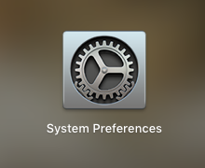

Select ‘Dictation & Speech’

’ 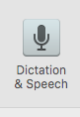
Select ‘Dictation’ and ‘On’

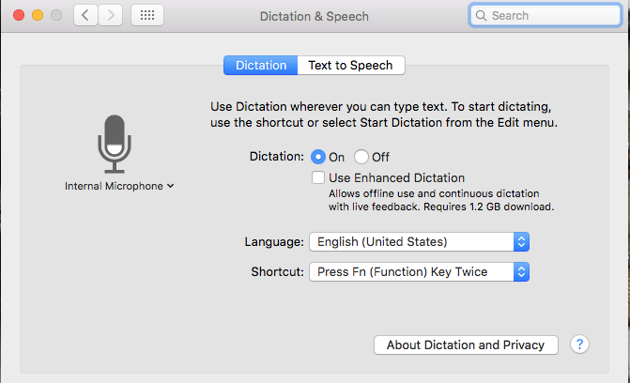

Free Speech-to-Text for Windows 10 (PC) Users

Under ‘Settings’
(for older versions of Windows go to ‘Control Panel’/’Ease of Access’/‘Speech Recognition’)

Select ‘Ease of Access’

Search ‘speech recognition’
(for older versions of Windows select ‘Speech Recognition’)

Select ‘Start Speech Recognition’ and ‘Set up your microphone’

