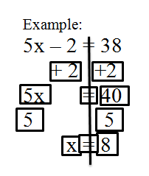
Directions:
- Cut out the pieces on the solid lines
- Solve the equation #1 and equation #2
using the pieces
- Glue the pieces to construction paper
***You may not use all of the pieces!***

= | x | -16
-16 | 4 | 4
4x | = | 32
8 | 16 | 4
4x = 32

-24 | +12 | =
-24b | 12 | +12
24 | b | =
-1 | 24 | 1
b - 12 = 12

