The Hope Chest Virginia

A quarterly newsletter from Project-HOPE VA

February 2023

Project HOPE-VA State Conference

March 6-8, 2023, Staunton, VA

Conference Details
We are so excited to see so many of our liaisons and other school employees who support students experiencing homelessness at our upcoming conference!
The registration has reached capacity and we have started a wait list. To join the wait list, please email mcbuffkin@wm.edu. We will fill vacancies in the order that we receive wait list requests.
Conference events include:
- ARP-HCY Funds panel and workshop
- “Liaisons and Lattes” networking event
- Numerous breakout sessions on topics such as Sustainability, Early Childhood, Family Engagement, Attendance, Title I, Transportation, English Learners, Navigating the COC, and more!
Keynote Speakers: Nationally recognized educators, Grace Lindsey, Tonya Young, Ryan Sykes, and Ann Masten.
We look forward to welcoming you and partnering with you!
For conference details including hotel information, please click here.
**If you are registered and have found that you can no longer attend, please contact mcbuffkin@wm.edu as soon as possible to open that reservation space.

Upcoming Training Events
Charlie Check-ins
February 14, 2023 at 10:00 a.m. & February 15, 2023 at 1:00 p.m. (repeat)
March 14, 2023 at 10:00 a.m. & March 15, 2023 at 1:00 p.m. (repeat)
April 11, 2023 at 10:00 a.m. & April 19, 2023 at 1:00 p.m. (repeat)
Please email homlss@wm.edu for the registration link.
Rural Connect (Rural Communities Sharing Group)
March 27, 2023 at 1 p.m. Please email kmmiller02@wm.edu for zoom link.
Communities of Practice
Consider joining a Community of Practice to share best practices around your ARP-HCY activities, troubleshoot the barriers that you are facing, and collaborate with liaisons from across Virginia.
CoP A: Attendance, Family Engagement, & School Stability, May 2, 2023 at 10 a.m.
CoP B: Underserved Populations, May 4, 2023 at 10 a.m.
CoP C: Student Achievement & Graduation, May 3, 2023 at 10 a.m.
Please email kmmiller02@wm.edu for zoom link.

ARP-HCY Activities

Spending Deadline: September 30, 2024

ARP-HCY funds provide a historic opportunity to create new activities that support the identification, enrollment and success of students experiencing homelessness in your LEA. Below are some ideas for ways to help your students and families get the support they need.
Local Staff Training - Consider using funds to host a summer McKinney-Vento training session for school staff with stipend and lunch provided for participants.
Student Enrichment - Pay for students to attend educational performances focused on music and the arts. Prioritize connecting students from underserved populations to these experiences.
Student Achievement - Connect students experiencing homelessness with Career and Technical Education courses and programs in your area. Click here to find a local career center in your region. Students can use this link to create a VA Career Works account.
For more ideas on innovative ways to plan ARP-HCY activities in your LEA, click here.

Hope Hero

Malora Horn
We recently had the chance to sit down with the Roanoke City Public Schools Mckinney-Veno Program Coordinator, Malora Horn, to talk about the Help the Homeless Fund. This fund not only serves as an additional resource to meet the needs of students and families experiencing homelessness, but also helps to raise awareness across Roanoke. Click below to watch our interview with Malora. You can also click here to learn more about the Help the Homeless Fund. Click the following link to view the interview: Video Link.

Underserved Populations
This is a spotlight on Students with Disabilities.
By Martha Crockett
While homelessness can negatively impact a variety of academic challenges across the span of K-12 schooling including attendance, achievement, and school dropout (Cumming & Gloeckner, 2012; Miller, 2011), one of the most significant consequences is the high school diploma (Murphy & Tobin, 2011). Children and youth with disabilities also face greater co-occurring health conditions and report more pain and lower quality of life in adulthood than their non-disabled peers (Rubenstein et al., 2022). Although two federal laws, The McKinney-Vento Act and the Individuals with Disability in Education Act, have been established to provide educational protection for students experiencing homelessness and students with disabilities, there are still gaps in both services offered and educational outcomes for these individuals.
In the 2021-22 school year, 1,091 out of 98,722 high school seniors across Virginia faced homelessness, and 12,321 had an IEP. 216 students experienced the overlap of homelessness and an IEP. According to Federal Graduation Indicator data, 88.99% of the general population, in contrast with 67.64% of students experiencing homelessness and 70.23% of students with an IEP, earned their diplomas that year (Virginia Department of Education [VDOE], n.d.). Graduation rates were even lower for students experiencing homelessness who had an IEP at 60.79%.
VDOE (n.d.) has been collecting disaggregated graduation data since 2008. These data can be found on the Cohort Graduation Build-A-Table site. The following visual comparisons underscore the ongoing nature of discrepancies in student achievement. The table below depicts the average high school graduation rates over the last 14 years of base students (those who do not identify in a particular reporting category), as well as individual and overlapping reporting categories.
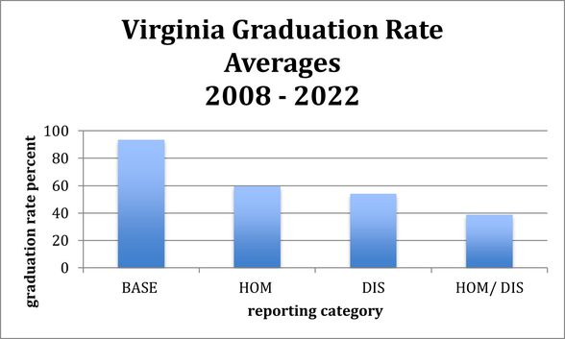
The same data, organized and presented differently in the figure below, again highlights the significant consequences of homelessness and disabilities both individually and together on high school graduation.
Students experiencing homelessness are more likely to have an IEP than their housed peers (NCHE, 2007). High mobility can delay identification of a student with a disability and such students may require more support during times of transition.
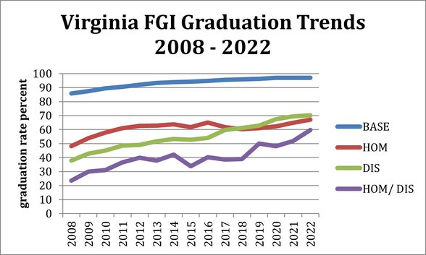
The recent Virginia document, “Intersection of McKinney-Vento and IDEA,” identified special education resources and considerations for serving students with disabilities who are experiencing homelessness.
Other resources include:
Navigating the Intersections of the McKinney-Vento Act and Individuals with Disabilities Education Act: Coordination to Help Homeless Children and Youth with Disabilities
School Help for Homeless Children with Disabilities: Information for Parents
Supporting Students Experiencing Homelessness Who Have Disabilities: Federal Provisions to Increase Access and Success
Supporting Students with Disabilities: Implementing IDEA
Unlocking Potential: What Families and Shelters Need to Know about Homelessness and Special Education
References
Cumming, J.M. & Gloeckner, G.W. (2012). Homeless high school students in America: Who counts? Administrative Issues Journal: Education, Practice, and Research, 2(2), 104-111. DOI: 10.5929/2012.2.2.9
Miller, P. (2011). A critical analysis of the research on student homelessness. Review of Educational Research, 81(3), 308-337. DOI: 10.3102/0034654311415120
Murphy, J.F. & Tobin, K.J. (2011). How homeless children and youth can succeed: Researchers and advocates have identified successful strategies for school enrolling homeless students. Phi Delta Kappan, 93(3), 32-37.
NCHE. (2007). Supporting students with disabilities: Implementing IDEA. National Center for Homeless Education. https://cpacinc.org/docs/Supporting-Homeless-Students-with-Disabilities.pdf
Rubenstein, E., Bock, E., Brochu, P., & Byrne, T. (2022). Quantifying the intersection of disability and homelessness in Massachusettsmlc public schools in 2018 – 2019. Child Care Health Development, 48, 569-577.
Virginia Department of Education (n.d.). Cohort graduation build-a-table. Virginia department of education. https://p1pe.doe.virginia.gov/apex_captcha/home.do?apexTypeId=305

Housing Vouchers
Some special housing vouchers may be available in your community. These vouchers provide rental assistance to low-income households.
Emergency Housing Vouchers help homeless and unstably housed households and those at risk of homelessness. Contact your local Continuum of Care organization for more information. Click here for more information.
Mainstream Vouchers help non-elderly persons (at least 18 and less than 62) who have disabilities and their families. Contact your local housing authority or housing agency for more information. Click here for more information.
For general information and assistance, reach out to ARP analyst Lynne Carruth at llcarruth@wm.edu.
Project HOPE-Virginia Virginia Department of Education The College of William and Mary – SOE P.O. Box 8795 Williamsburg, VA 23187-8795 Office: (757) 221-4002 Fax: (757) 221-5300 Toll Free in Virginia (877) 455-3412 homlss@wm.edu
Project HOPE-Virginia is Virginia’s Program for the Education of Homeless Children and Youth. The College of William and Mary administers the program for the Virginia Department of Education. Funding is authorized under the McKinney-Vento Homeless Education Act, Title X, Part C of the No Child Left Behind Act (P.L. 107- 110). The purpose of Project HOPE-Virginia is to ensure the enrollment, attendance, and success of homeless children and youth in school.

